1, Install IIS on Windows System
- To open the Windows Features dialog box, click Start, and then click Control Panel.
- In the Control Panel, click Programs.
- Click Turn Windows features on or off.
- Select Internet Information Services, and then click OK.
(Make sure to check on “ASP.NET” as below figure)
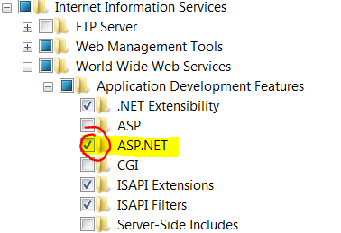
2, Install .net framework4.5
http://www.visualstudio.com/downloads/download-visual-studio-vs#net-45
3, Install MySQL
http://dev.mysql.com/downloads/workbench/
3, Data Import/Restore in MySQL
- Open MySQL Workbench
- Click “Data Import/Restore”, set the file path, and then click “Start Import”
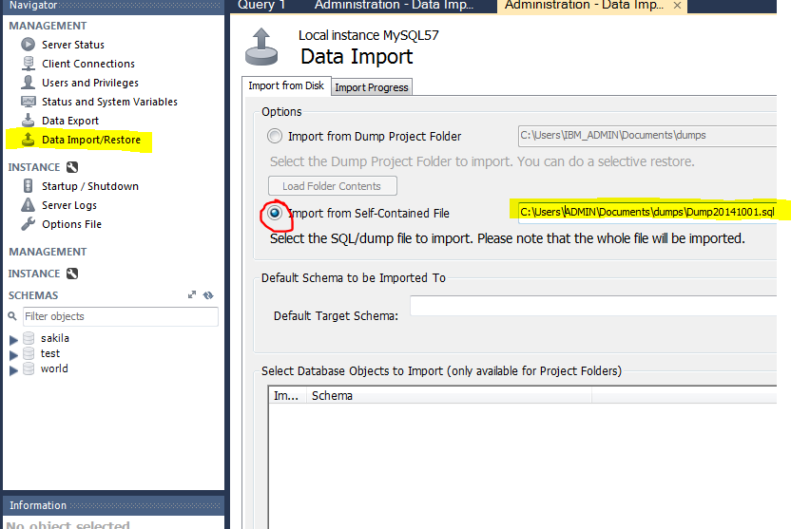

- After import completed, refresh the schemas list, you will find the new database.
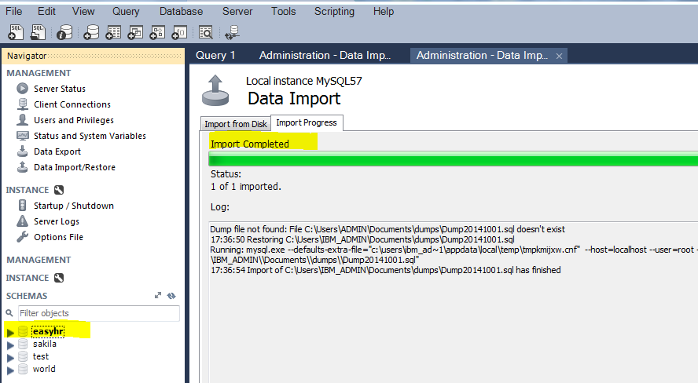

4, Host ASP.Net Web API on IIS Server
- open the Internet Information Services (IIS) manger
- Add Web Site: Right Click “Sites”, then select “Add Web Site”.
Write the "Site name" and provide the Physical path, and change the default port to new port "8080". Now click on the "OK" button.
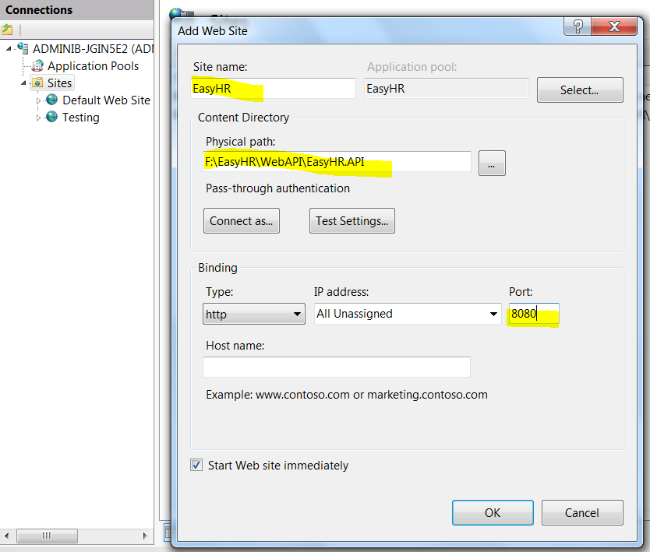

- Edit Application Pool which used by our new web site, Select the ".NET Framework version" that is ".NET Framework v4.0.30319" and "Managed pipeline mode" as "Integrated".

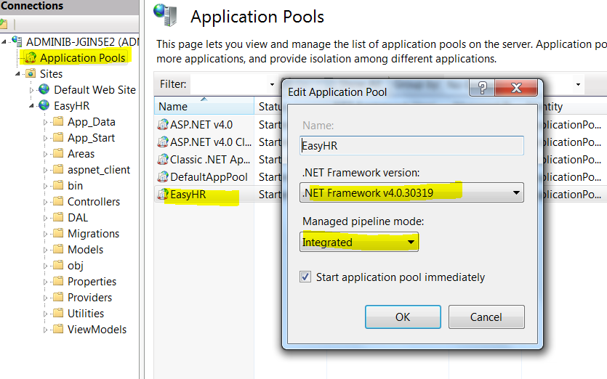
- Browse our application:
Right-Click our web site, select "Manage Web Site" -> "Browse".
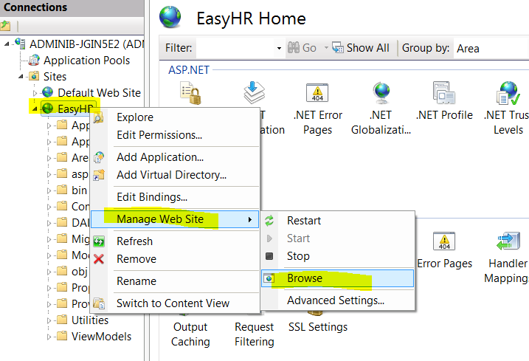
You will the url address as: http://localhost:8080, change it to: http://localhost:8080/help. It looks like this:
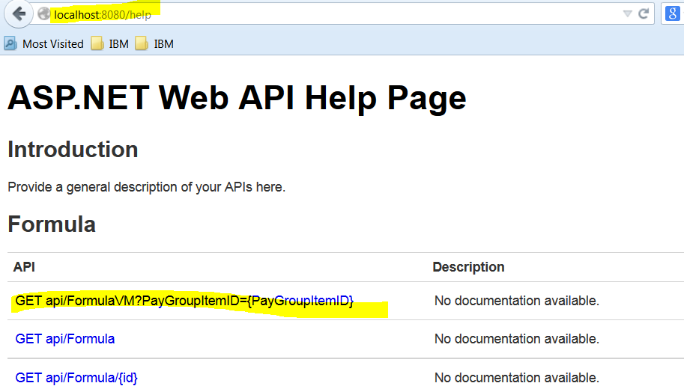

5, Test the WebAPI on Fiddler
click on the Compose tab and enter the URL:
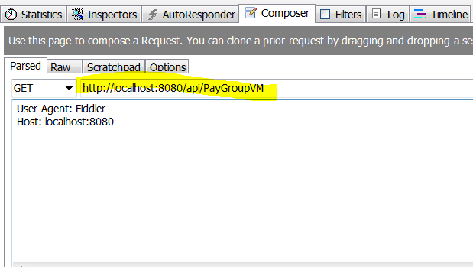
The output looks like this:
